EAP8518A-FLF-17 Access Point
Firmware Release Notes

Version 1.1.0.23
Version 1.2.0.23

Release Date: June, 07, 2011
Introduction:

The EAP8518 Access Point provides single-radio channel support, which improves transmission data rates and wireless converges. It is designed to provide a best wireless access and stable environment with a high bandwidth wireless access.

Firmware Specification:

Status | Version No. | Release Date | History
Current version | 1.1.0.23  1.2.0.23 | 06/07/2011 | [IP] Remove message: If we configure IP twice, console will show a warning message.  - [DUT] user must input “null” in old password field to change password in WEB UI.  - [DUT] if there is a “#” in system name string, the string behind “#” will disappear after DUT reboot.  - [CLI] Bug-Fix: up/down button is not working.
 |  | 03/11/2011 | [MIB] improve some private MIB objects performance(get/set)  - [MIB]bug-fix: VAP admin status can enable just VAP0  - [MIB]bug-fix: VAP close system can enable just VAP0  - [MIB] some private MIB objects in wireless and VAP table will take effect after user set MIB object  - [WEP] bug-fix: hex 128bit key couldn’t set normally  - [WEB/CLI] bug-fix:VLAN ID display issue  - [MIB] bug-fix : WEP key just can set ASCII 64bit key.
 | 1.1.0.21  1.2.0.21 | 01/07/2010 | 1. [WEB & CLI] Bug Fix: VLAN id display issue  2. [Platform] RAM and Flash are exchange in future EAP8518. Therefore, Product name and version number are divided .  3. [ WEB & CLI] Add warning message for firmware upgrade (2 version firmware for different flash)  4. [WEB] Bug Fix: UI doesn’t show error message when firmware upgrade fail.
 | 1.1.0.19 | 05/19/2010 | 1. [System] Web/CLI Administration and VAP security mode password support new special character ‘# ‘.
 | 1.1.0.18 | 05/04/2010 | [AP] improvement: if many stations associated to AP with heavy traffic for long time, some stations are difficult to connect to AP.  - [AP] improvement: Sometimes station associated to AP and fail to get IP from DHCP server, but station can access internet if set IP as static IP .  - [System] add a new login account to restore configuration to factory default  - [System] Bug fix: user can export configuration file from AP, but can’t import the configuration file into AP.
 | 1.1.0.14 | 10/22/2009 | - [System] disable 5600~5650MHZ channel to meet FCC DFS requirement (avoid to make interference with weather radar)
 | 1.1.0.13 | 06/05/2009 | - [System] Change default IP address : 192.168.2.1 (SMC)  - [CLI] Fix IP address displaying problem.  - [WDS] The WDS link will be broken after changing the radio or VAP settings when WPA(2)-PSK and STP were enabled. (Fixed)  - [WEB/CLI] Change default settings: LLDP disabled
 | 1.1.0.12 | 28/04/2009 | - [WEB] Show warming message box to inform user exactly 64 hex numbers can be input when WPA-PSK key length over 64.  - [WEB/CLI] Change factory default config settings : 1. WMM : Disable, 2. Local Bridge Filter: Disable  - [VLAN] wSTA cannot acquire ip address through DHCP while Local Bridge Filter and VLAN were enabled. (Fixed)  - [WEB/CLI] When input RADIUS key with 64 characters and press set button on EAP. wSTA fails to authenticate with WAP-EAP authencation methods. (Fixed)  - [CLI] Remove commnad “configure dhcp”. Add dhcp-relay command to configure dhcp relay settings under each VAP. Remove “show dhcp” commnd. Show dhcp-relay settings under each VAP.
 | 1.1.0.11 | 15/04/2009 | - [WEB/CLI] Fix bug of WPA preshared key can accept length of 8~63 hex numbers in VAP settings. Only hex key with length 64 is acceped.  - [WEB/CLI] Recover Fragment Length settings in Radio Settings for fine tuning performance under interference. The default length is 2346 (fragment function disabled).  - [WEB/CLI] Remove Protection Method option of CTS-only or RTS/CTS in Radio Settings. The default method supports RTS/CTS.  - [WEB] Fix the maximum RTS Threshold to 2347 in Radio Settings. The default value is 2347.  - [WDS] Fix bug of WDS link can not auto recover when connection establish with WPA(2)-PSK approach.  - [DFS] Fix bug of only 2 VAPs can be enabled when select DFS channels in 5G band.  - [CLI] Fix bug of TX power value displayed through CLI show command.
 | 1.1.0.8 | 31/03/2009 | - [System] The MAC addresses assigned to VAPs were changed from “locally administrated addresses” to “universally administrated addresses”.
 | 1.1.0.6 | 23/03/2009 | - [DFS] Imrpove radar type 5 singal detection rate in ETSI and FCC DFS pre-scan.  - [DFS] Imrpove radar bin5 signal detection rate of UNII Detection Bandwidth in FCC DFS pre-scan.  - [DFS] CAC time 10 minnutes in 5600-5650 MHZ to meet DFS3 requirements for ETSI (Final draft ETSI EN 301 893 v1.5.1)  - [802.11n WiFi IOT] 4.2.11 Pre-authencation (fixed)  - [802.11n WiFi IOT] 4.2.13 WPA Specific Countermeasure (fixed)  - [WDS] 2 WDS-STAs which connect to the same WDS-AP fail to ping with each other in the PtoMP mode. (fixed)  - [WEB] To fill in length 64 numbers with wpa/wpa2 psk hex but pop-up a warning message shows wap key should be 8~63 (fixed)  - [WEB] Re-design WEB interfaces.
 | 1.1.0.1 | 10/02/2009 | [1] Improve 802.11n IOT connection issues with Intel, Broadcom and Ralink 802.11n client cards.  [2] CLI interface for showing Bridge and STP status.  [3] Fix bug of wSTA fail to complete 802.11 x authentications when VLAN and WDS enabled.
 | 1.0.0.1 | 13/01/2009 | [1] Fix problem of getting IP address for wireless stations through DHCP when VLAN enabled.  [2] Reorganiz STP WEB settings for “port priority” and “path cost settings” of ethernet interface.  [3] WEB/CLI support configuring “port priority” and “path cost” for wireless VAP in STP seetings.  [4] WEB/CLI support WPA/WPA2 mixed mode security options.  [5] [Feature] Firmware upgrades protection for different customers.
 | 0.5.6.1 | 23/12/2008 | [1] Fix WDS connection problem.  [2] According to SMC’s request, change the behavior of native VALN to untag.  [3] STP is supported when WDS enabled.  [4] Unify description of WMM mode in WEB and CLI  [5] Unify description for LLDP in WEB and CLI.  [6] Remove option of WEP key 152 bits from WEB/CLI in VAP settings
 | 0.5.5.8 | 08/12/2008 | [1] Support TX Power limit settings in Radio section of WEB/CLI  [2] Fix WDS bug; support WPA-PSK TKIP

Accessing AP through Console Port

To access AP through a console port, please use the following settings:

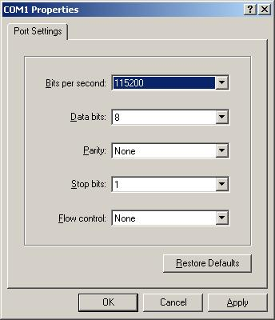

Note: The console port is the RJ-45 port away from the power jack.

Default login name and password

The default login name/password applies to both WEB and CLI.
Login Name | admin
Password | smcadmin

If user forgot the username and/or password, user can login via following account to reset to factory default, but all other configurations will also be restored (reset) too.
Login Name | restore
Password | password

Firmware Upgrade Procedure:

There are two methods to upgrade firmware. Please do not turn off power during a firmware upgrade.

- Upgrade firmware through web:

Upgrade the firmware from “Local” file option.

Refer to the following graph, select MAINTENANCE → Firmware, and select the file from browser option, then press “Start Upgrade”, until the complete message pops-up.
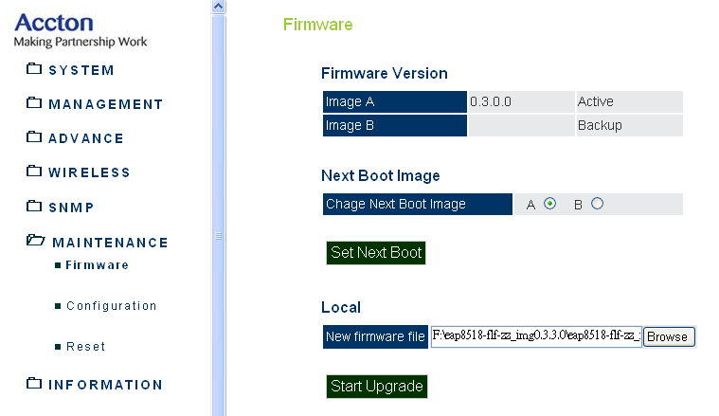

Upgrade from “Remote” option
Refer to the following graph, select MAINTENANCE → Firmware, and specify the related information, then press “Start Upgrade”, until the complete message pops-up.

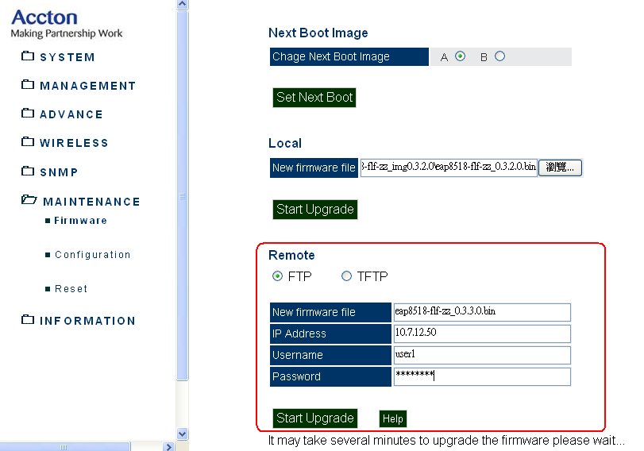

Note: Upgrading the firmware from WEB does not overwrite the existing configuration. To reset the configuration to default, please go to MAINTENANCE → Configuration, select “Restore Factory Setting”.

- Upgrade firmware through u-boot: (Engineer use only)
This method is used only when system cannot bootup (power-on) successfully.
Be careful, it will cause the system crash and cannot recover for the wrong commands.
  - Check current bootup Indicator before upgrade

ar7100> DID

  - Change bootup Indicator(choose A or B)

ar7100> DI
Start setting Bootup Indicator.....
Bootup Indicator <image-B>:

  - If we want to upgrade B partition：
Please check bootup indicator is B

    - Prepare the download environment：

ar7100> setenv ipaddr 10.7.12.41 (10.7.12.41 is a sample for the device’s ip address)
ar7100> setenv serverip 10.7.12.50 (10.7.12.50 is a sample for the ip address of tftp server)
ar7100> setenv bootargs console=ttyS0,115200 root=31:06 rootfstype=jffs2 init=/sbin/init mtdparts=ar9100-nor0:192k(u-boot),64k(env-A),2048k(APConfig),2048k(uImageA),13056k(rootfsA),2048k(uImageB),13056k(rootfsB),64k(env-B),64k(bootup),64k(board-data),64k(ART)
ar7100> setenv bootcmd bootm 0xbf100000
ar7100> saveenv

    - Download kernel and file system：

There are two files - “ap83fus-jffs2” (file system) and “vmlinux.gz.uImage” (kernel)
# load image to address and burn the kernel onto flash
ar7100> erase 0xbf100000 +0x200000
ar7100> tftp 0x80200000 vmlinux.gz.uImage
ar7100> cp.b 0x80200000 0xbf100000 0x200000

# load image to address and burn the file system onto flash
ar7100> erase 0xbf300000 +0xcc0000
ar7100> tftp 0x80200000 ap83fus-jffs2
ar7100> cp.b 0x80200000 0xbf300000 0xcc0000

  - If we want to upgrade A partition：
Please check bootup indicator is A

    - Prepare the download environment：

ar7100> setenv ipaddr 10.7.12.41 (10.7.12.41 is a sample for the device’s ip address)
ar7100> setenv serverip 10.7.12.50 (10.7.12.50 is a sample for the ip address of tftp server)
ar7100> setenv bootargs console=ttyS0,115200 root=31:04 rootfstype=jffs2 init=/sbin/init mtdparts=ar9100-nor0:192k(u-boot),64k(env-A),2048k(APConfig),2048k(uImageA),13056k(rootfsA),2048k(uImageB),13056k(rootfsB),64k(env-B),64k(bootup),64k(board-data),64k(ART)
ar7100> setenv bootcmd bootm 0xbe240000
ar7100> saveenv

    - Download kernel and file system：

There are two files - “ap83fus-jffs2” (file system) and “vmlinux.gz.uImage” (kernel)
# load image to address and burn the kernel onto flash
ar7100> erase 0xbe240000 +0x200000
ar7100> tftp 0x80200000 vmlinux.gz.uImage
ar7100> cp.b 0x80200000 0xbe240000 0x200000

# load image to address and burn the file system onto flash
ar7100> erase 0xbe440000 +0xcc0000
ar7100> tftp 0x80200000 ap83fus-jffs2
ar7100> cp.b 0x80200000 0xbe440000 0xcc0000

  - Download default configuration – config.jffs2

# load config file and burn the config to flash
ar7100> erase 0xbe040000 +0x200000
ar7100> tftp 0x80200000 config.jffs2
ar7100> cp.b 0x80200000 0xbe040000 0x200000

Default Configuration Settings:

The following table lists some default configuration settings:

IP | 192.168.2.1
Net mask | 255.255.255.0
telnet | Enabled
SSH | Enabled
http | Enabled
Syslog | Disabled
11ng default channel | 11
11ng operation mode | HT20
Short Guard Interval | Enabled
A-MPDU | Enabled
A-MPDU limit | 65535
A-MSDU | Enabled
A-MSDU limit | 4096

Default configuration will only enable 1 VAP.

Improvements and Bugs Fixed
V1.1.0.23 & V1.2.0.23

[IP] Remove message: If we configure IP twice, console will show a warning message.
- [DUT] user must input “null” in old password field to change password in WEB UI.
- [DUT] if there is a “#” in system name string, the string behind “#” will disappear after DUT reboot.
- [CLI] Bug-Fix: up/down button is not working.

V1.1.0.22
1. [MIB] improve some private MIB objects performance(get/set)
2. [MIB] bug-fix: VAP admin status can enable just VAP0
3. [MIB] bug-fix: VAP close system can enable just VAP0
4. [MIB] some private MIB objects in wireless and VAP table will take effect after user set MIB object
5. [WEP] bug-fix: hex 128bit key couldn’t set normally
6. [WEB/CLI] bug-fix:VLAN ID display in wrong place in WEB UI, and display wrong value in CLI
7. [MIB] modify WEP key setting:
User just set 1.3.6.1.4.1.259.10.3.1.5.2.1.13 open, 1.3.6.1.4.1.259.10.3.1.5.2.1.14 wep(1), and
set the key to 1.2.840.10036.1.3.1.2 (5 or 13 length Ascii string,10 or 26 hex string).

V1.1.0.21 & V1.2.0.21
1. [WEB & CLI] Bug Fix: VLAN id display issue
2. [Platform] RAM and Flash are exchange in future EAP8518. Therefore, Product name and version number are divided . Please don’t try to upgrade incorrect version firmware.
 | New Platform | Old Platform
Product Name | EAP8518A-FLF-17R2 | EAP8518A-FLF-17
Version Number | 1.2.0.X | 1.1.0.X

3. [ WEB & CLI] Add warning message for firmware upgrade (2 version firmware for different flash). If user want to upgrade 1.2.0.X firmware to old EAP8518(SAMSUNG Flash), UI will show message --“Firmware upgrading failed!! Please check the label pasted in the bottom of SMCE21011. Please get the firmware with -V2.”. If user want to upgrade 1.1.0.X firmware to new EAP8518(MXIC Flash), UI will show “Firmware upgrading failed!! Please check the label pasted in the bottom of SMCE21011. The firmware of -V2 should be used for SMCE21011-V2 hardware.”.
4. [WEB] Bug Fix: UI doesn’t show error message when firmware upgrade fail.

V1.1.0.19

1. [System] Administration login password and VAP security mode WEP/WPA-PSK key support new special character ” ` ” , ” # ”.

V1.1.0.18
- [AP] improvement—if many stations associated to AP with heavy traffic for long time, some stations are difficult to connect to AP
- [AP] improvement: Sometimes station associated to AP and fail to get IP from DHCP server, but station can access internet if set IP as static IP
- [System] Currently HW reset button do not support restore factory default configuration ,to work around this issue, add a new login account :
    - Username: restore
    - Password: password
If user login via this account, system will auto restore configuration to factory default when login
- [System] Bug fix—user can export configuration file from AP, but can’t import the configuration file into AP

V1.1.0.14
- [System] disable 5600~5650MHZ channel to meet FCC DFS requirement ( avoid to make interference with weather radar)

V1.1.0.13
- [System] Change default IP address : 192.168.2.1 (SMC)
- [CLI] Fix IP address displaying problem.
- [WDS] The WDS link will be broken after changing the radio or VAP settings when WPA(2)-PSK and STP were enabled. (Fixed)
- [WEB/CLI] Change default config settings: LLDP disabled

V1.1.0.12
- [WEB] Show warming message box to inform user exactly 64 hex numbers can be input when WPA-PSK key length over 64.
- [WEB/CLI] Change factory default config settings : 1. WMM : Disable, 2. Local Bridge Filter: Disable
- [VLAN] wSTA cannot acquire ip address through DHCP while Local Bridge Filter and VLAN were enabled. (Fixed)
- [WEB/CLI] When input RADIUS key with 64 characters and press set button on EAP. wSTA fails to authenticate with WAP-EAP authencation methods. (Fixed)
- [CLI] Remove commnad “configure dhcp”. Add dhcp-relay command to configure dhcp relay settings under each VAP. Remove “show dhcp” commnd. Show dhcp-relay settings under each VAP.

V1.1.0.11
- [WEB/CLI] Fix bug of WPA preshared key can accept length of 8~63 hex numbers in VAP settings. Only hex key with length 64 is acceped.
- [WEB/CLI] Recover Fragment Length settings in Radio Settings for fine tuning performance under interference. The default length is 2346 (fragment function disabled).
- [WEB/CLI] Remove Protection Method option of CTS-only or RTS/CTS in Radio Settings. The default method supports RTS/CTS.
- [WEB] Fix the maximum RTS Threshold to 2347 in Radio Settings. The default value is 2347.
- [WDS] Fix bug of WDS link can not auto recover when connection is established with WPA(2)-PSK mode.
- [DFS] Fix bug of only 2 VAPs can be enabled when select DFS channels in 5G band.
- [CLI] Fix bug of TX power value displayed through CLI show command.

V1.1.0.8
- [System] The MAC addresses assigned to VAPs were changed from “locally administrated addresses” to “universally administrated addresses”.

V1.1.0.6
- [DFS] Imrpove radar type 5 singal detection rate in ETSI and FCC DFS pre-scan.
- [DFS] Imrpove radar bin5 signal detection rate of UNII Detection Bandwidth in FCC DFS pre-scan.
- [DFS] CAC time 10 minnutes in 5600-5650 MHZ to meet DFS3 requirements for ETSI (Final draft EN 301 893 v1.5.1)
- [802.11n WiFi IOT] 4.2.11 Pre-authencation (fixed)
- [802.11n WiFi IOT] 4.2.13 WPA Specific Countermeasure (fixed)
- [WDS] 2 WDS-STAs which connect to the same WDS-AP fail to ping with each other in the PtoMP mode. (fixed)
- [WEB] To fill in length 64 numbers with wpa/wpa2 psk hex but pop-up a warning message shows wap key should be 8~63 (fixed)
- [WEB] Re-design WEB interfaces.

V1.1.0.1
- [WLAN] Improve 802.11n IOT connection issues with Intel, Broadcom and Ralink 802.11n client cards.
- [CLI] CLI interface for showing Bridge and STP status.
- [VLAN] Fix bug of wSTA fail to complete 802.11 x authentications when VLAN and WDS enabled.

V1.0.0.1
- [VLAN] Fix problem of getting IP address for wireless stations through DHCP when VLAN enabled.
- [WEB/CLI] Reorganiz STP “port priority” and “path cost” settings for ethernet interface.
- [WEB/CLI] Support configuring “port priority” and “path cost” for wireless VAP in STP seetings.
- [WEB/CLI] Support WPA/WPA2 mixed mode security options.
- [Feature] Firmware upgrades protection for different customers.

V0.5.6.1
- [WDS] Fix WDS connection problem.
- [VLAN] According to SMC’s request, change the behavior of native VALN to untag.
- [STP] STP is supported when WDS enabled.
- [WEB/CLI] Unify description of WMM mode in WEB and CLI (ERP#57)
- [WEB/CLI] Unify description for LLDP in WEB and CLI. (EPR#48)
- [WEB/CLI] Remove option of WEP key 152 bits from WEB/CLI in VAP settings

V 0.5.5.8
- [WEB/CLI] Support manual TX Power limit settings in Radio section of WEB/CLI
- [WDS] Fix connection problem when setting WPA(2)-PSK TKIP

Restrictions and Limitation
- When running stress test in 2.4G environment with 32 mixed types of wSTAs (b/g/n) and mixed mode security settings(WEP, WPA-PSK[TKIP], WPA2-PSK[AES], WPA-EAP[TKIP) and WPA2-EAP[AES]), some wSTAs may hard to reconnect to AP after long periods (50hrs).

- [Feature] Neighbor, rogue AP detection, and ad-hoc detection are disabled due to backgroung scan defect in wifi driver.
Beacons will disappear after doing background scan.

- Max number of stations - 64 wireless stations allowed whole system.

- VAP configuration
- Max number of configurable VAPs is 8.

- Super AG is not supported in current SDK, please use 11n standard's high throughput mode (HT20 or HT40).

- The performance is poor when encryption was set as TKIP or WEP in VAP.
When encryption was configured as TKIP or WEP, the link rate is low, and the performance is poor in high throughput mode.

- 80211/Private MIB functions are not completed.

- SNMPv3 is not yet supported.

- Need to explicitly save user’s configuration.
When the configuration is changed, it will not be stored automatically into the permanent storage -- the flash. Instead, the user must explicitly use a CLI (or WEB) command to save the new configuration to storage.

CLI command: copy running startup
WEB page:
  - Save from configuration
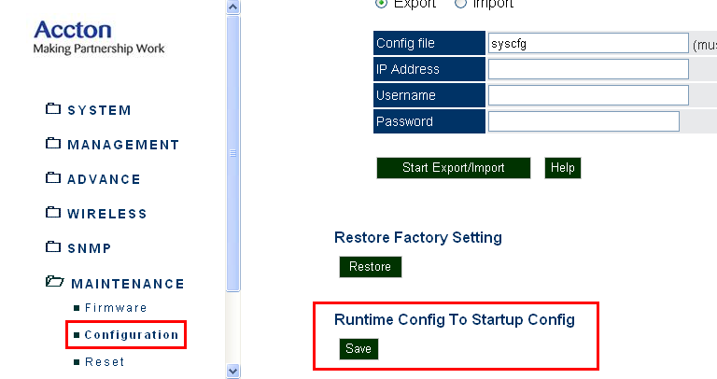

  - Save before system reboot
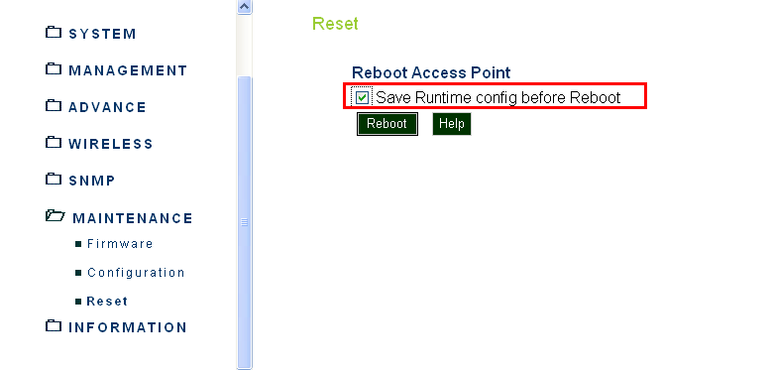

Known Issues
- WEB operation may have slow response
Currently, the operation seems slow when activating the changes of Radio, VLAN and VAP settings.

- User may configure 2 VAPs with the same SSID.

Feature Status

Features | Status | Notes
1. System
1.1 Administration | Ready
1.2 AP Management | Ready
1.3 MAC Authentication | Ready
1.4 Filter Control | Ready
1.5 System Log | Ready
1.6 System Time | Ready
1.7 VLAN | Ready | 1. dynamic (guest) VLAN not supported  2. Native VLAN untag
1.8 ACL | Ready
1.9 Quick Setup | Ready | Quick setup only for WEB UI.
1.10 SVP | Ready | Feature implemented, but not verified.
1.11 LLDP | Ready
2. Network
2.1 TCP/IP Setting | Ready
2.2 Spanning Tree Protocol | Ready
3. Wireless
3.1 Radio Setting (11na) | Ready
3.2 Radio Setting (11ng) | Ready
3.3 VAP Setting | Ready
3.4 Security | Ready | When set WEP/TKIP will cause low link rate and low throughput. (around 20Mbps)
3.5 Authentication | Ready
3.6 Radius | Ready
3.7 Throughput |  | [11NA]  11NAHT20 : 47 Mbps  11NAHT40: 106 Mbps  [11NG]  11NGHT20 : 55 Mbps  11NGHT40 : 96 Mbps
3.8 WMM | Ready | WiFi certified (WFA7369)
3.9 System and function interoperability | Ready | WiFi certified (WFA7369)
3.10 WDS | Ready
3.11 DFS3 | Ready | CE:  Compliance with ETSI EN 301 893 V1.5.1  FCC:  Compliance with IC RSS-210 Section 6.2.2
4. SNMP
4.1 SNMP security | Not ready | TBD
4.2 Trap function | Not ready | TBD
4.3 MIBs implement | Not ready | TBD
5. Mainteance
5.1 Firmware | Ready
5.2 Configuration | Ready
5.3 Reset | Ready
6. Status
6.1 AP Status | Ready
6.2 Station Status | Ready
6.3 Event Log | Ready

Sample CLI Commands

Action | Commands
Set ip mode to static | configure  interface ethernet  no ip dhcp
Set ip address, netmask and gateway | configure  interface ethernet  ip address 10.7.13.21 255.255.255.0 10.7.13.254
Select channel and HT mode | configure  interface wireless 0  channel HT40 ? ➔  channel HT40 44Plus
Set beacon interval | Accton# configure  Accton(config)# interface wireless 0  Accton(if-wireless 0)# beacon-interval 1000
Set DTIM period | Accton# configure  Accton(config)# interface wireless 0  Accton(if-wireless 0)# dtim-period 255
Set fragmentation length | Accton# configure  Accton(config)# interface wireless 0  Accton(if-wireless 0)# fragmentation-length 2346
Set RTS threshold | Accton# configure  Accton(config)# interface wireless 0  Accton(if-wireless 0)# rts-threshold 2347
Set Short Gurad Interval | Accton# configure  Accton(config)# interface wireless 0  Accton(if-wireless 0)# short-guard-interval Disable/Enable
Set A-MPDU enable/disable | Accton# configure  Accton(config)# interface wireless 0  Accton(if-wireless 0)# A-MPDU Disable/Enable
Set A-MPDU limit | Accton# configure  Accton(config)# interface wireless 0  Accton(if-wireless 0)# A-MPDU length 65535
Set A-MSDU enable/disable | Accton# configure  Accton(config)# interface wireless 0  Accton(if-wireless 0)# A-MSDU Disable/Enable
Set A-MSDU limit | Accton# configure  Accton(config)# interface wireless 0  Accton(if-wireless 0)# A-MSDU length 4096
To make RF setting changes effective | Accton# configure  Accton(config)# interface wireless 0  Accton(if-wireless 0)# vap 0  Accton(if-wireless 0: VAP[0])# make-security-effective enabled

